ARTIFICIAL INTELLIGENCE

What is AI?

Artificial intelligence, or AI, is technology that enables computers and machines to simulate human intelligence and problem-solving capabilities.

On its own or combined with other technologies (e.g., sensors, geolocation, robotics) AI can perform tasks that would otherwise require human intelligence or intervention. Digital assistants, GPS guidance, autonomous vehicles, and generative AI tools (like Open AI's Chat GPT) are just a few examples of AI in the daily news and our daily lives.

As a field of computer science, artificial intelligence encompasses (and is often mentioned together with) machine learning and deep learning. These disciplines involve the development of AI algorithms, modeled after the decision-making processes of the human brain, that can ‘learn’ from available data and make increasingly more accurate classifications or predictions over time.

Artificial intelligence has gone through many cycles of hype, but even to skeptics, the release of ChatGPT seems to mark a turning point. The last time generative AI loomed this large, the breakthroughs were in computer vision, but now the leap forward is in natural language processing (NLP). Today, generative AI can learn and synthesize not just human language but other data types including images, video, software code, and even molecular structures.

Applications for AI are growing every day. But as the hype around the use of AI tools in business takes off, conversations around ai ethics and responsible ai become critically important. For more on where IBM stands on these issues, please read Building trust in AI.

White paperWhy AI governance is a business imperative for scaling enterprise AI

Learn about barriers to AI adoptions, particularly lack of AI governance and risk management solutions.

Related content

Register for the guide on foundation models



[This Photo](https://www.noulakaz.net/2011/10/25/john-mccarthy-is-dead/) by Unknown Author is licensed under [CC BY-SA-NC](https://creativecommons.org/licenses/by-nc-sa/3.0/)

REALISE DATE OF A.I

29-JUNE-2001

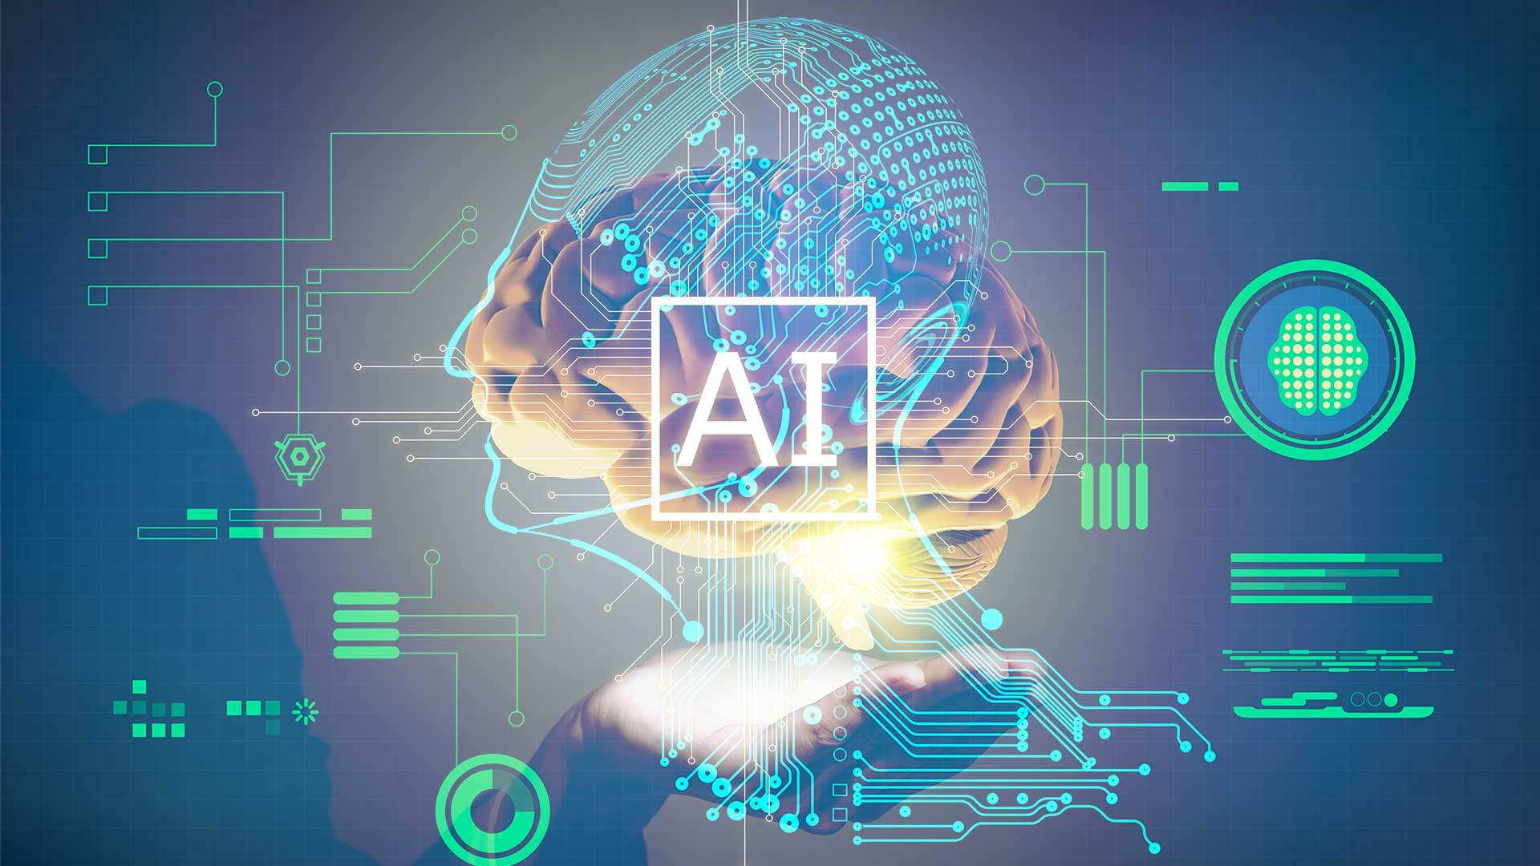

[This Photo](https://apicciano.commons.gc.cuny.edu/2019/08/28/rockefeller-institute-deja-vu-artificial-intelligence-what-can-we-learn-from-the-digital-revolution/) by Unknown Author is licensed under [CC BY-SA-NC](https://creativecommons.org/licenses/by-nc-sa/3.0/)

Importance of Artificial Intelligence

In computer science and computers, the term artificial intelligence has played a very prominent role. The term has become more popular due to recent advances in Artificial Intelligence and Machine Learning.

Machine learning is the area of artificial intelligence where machines are responsible for completing daily tasks and are believed to be smarter than humans.

They are known to learn, adapt and perform much faster than humans and are programmed to do so. Robotics and integration with IoT devices have taken machines to think and work to a new level where they out-perform humans in their cognitive abilities and smarts.

In this article, we will read about the huge importance of artificial intelligence.

## How Does AI Work?

Artificial intelligence systems work by using algorithms and data. First, a massive amount of data is collected and applied to mathematical models, or algorithms, which use the information to recognize patterns and make predictions in a process known as training. Once algorithms have been trained, they are deployed within various applications, where they continuously learn from and adapt to new data. This allows AI systems to perform complex tasks like image recognition, language processing and data analysis with greater accuracy and efficiency over time.